Milestone 3 Worksheet

Part I: Selecting a Sample

1.
I will compare houses from their features and the cost within Chicago Ridge, IL which is my neighborhood. When you search for houses in the whole city for the same features, they may vary from one neighborhood to another but when you limit yourself to one locality you limit the chances of your sample being biased.

2.

Homes | Sale Prices | Features | Square Feet | Price Per Sq. Foot (PPSF)(x) | (x-mean(130.065)) | (x-mean)²
Your House | $140,000 | 2br, 2bath, condo | 1000 | 140.061
Comp 1 | $95,000 | 2br, 2bath, condo | 850 | 111.765 | -18.3 | 334.89
Comp 2 | $69,900 | 2br, 2bath, condo | 1000 | 69.9 | -60.165 | 3619.83
Comp 3 | $144,900 | 2br, 2bath, condo | 1000 | 144.9 | 14.835 | 220.08
Comp 4 | $149,900 | 2br, 2bath, condo | 1200 | 124.917 | -5.148 | 26.50
Comp 5 | $124,000 | 2br, 2bath, condo | 1100 | 112.727 | -17.338 | 300.61
Comp 6 | $109,000 | 2br, 2bath, condo | 1020 | 106.863 | -23.202 | 538.33
Comp 7 | $156,122 | 2br, 2bath, condo | 977 | 159.797 | 29.732 | 883.99
Comp 8 | $169,900 | 2br, 1bath, condo | 827 | 205.441 | 75.376 | 5681.54
Comp 9 | $178,145 | 2br, 1bath, condo | 1040 | 171.293 | 41.228 | 1699.75
Comp 10 | $83,743 | 2br, 1bath, condo | 900 | 93.048 | -37.017 | 1370.26
Totals | $1280610 |  |  |  |  | 14675.78

Part 2: Finding your Sample Parameters

Using your sample above, let’s calculate some measures of central tendency. Zillow lists median property values for each neighborhood on their website, which will be helpful in seeing if our sample is representative of our population.
- Calculate and explain how to find the mean of your sample.

The mean is calculated by adding up all the prices of the houses and dividing them by the number of houses in the sample (10).
Mean = 1280610/10 = $128,061

- Calculate and explain how to find the median of your sample.

The median value of the sample will be calculated by arranging the values in ascending order, then find the mean of the 5th and 6th values.
Median=$178,145, $169,900, $156,122, $149,900, $144,900, $124,000, $109,000, $95,000, $83,743, $69,900
= ($144,900 + $124,000)/2 = $134,450

- What is the median price for similar homes listed in your neighborhood? (find this on Zillow):
- $59,000
- What is the sampling error for the median (the difference between the Zillow median and your sample median) of your ten homes? $10,900

Given your sampling error, do you think your sample is representative of the market in your city/neighborhood? Explain in 2-3 sentences below.

The sample is not a good representation of the population of Chicago Ridge, IL house values. A difference of $10,900 is huge and means that the sample did not represent the values of the houses well. A good error would be below $5,000.

Now we are going to look at the price per square foot (PPSF) of your properties. Let’s find the mean, variance, and standard deviation for these homes.
List the price per square foot for your properties to the right:
Next find the mean price per square foot of your properties: $130.065

Now for the calculations! Show all of your work to find the variance below (note that n=9, since this is a sample… remember that n is the number that you divide by in the formula)

The other working are on the table above
Variance = ∑ (x-mean)²/n
∑ (x-mean)² =14675.78, n=9
Variance = 14675.78/9 = 1630.64

Finally take the square root of your variance to find the sample standard deviation:

Standard deviation = √1630.64 = 40.38

Part 3: Using your Sample to Guess Whether your Property is a Good Deal!

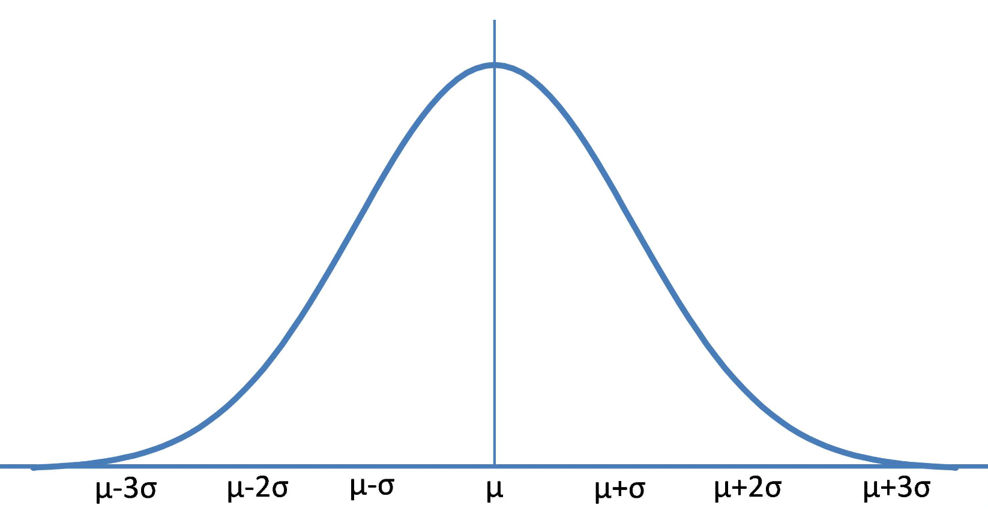
250
10
50
90
130.065
210
170

So, if my sample is pretty accurate to the entire population of houses in my neighborhood, I should expect the price per square foot of my home to be between $10 and $250 per square foot.

$z=\frac{your house PPSF-mean house PPSF}{standard deviation of PPSF}$.

Z = (140.000- 130.065)/40.38
Z = 9.935/40.38 = 0.246 =0.25

So now, find the z-score for the dream property you identified in Milestone 1: 0.25

Z 0.25 = 0.5987 *100 = 59.87%

Using a z-score table, your house is more expensive than 59.87% of properties in your neighborhood, by estimation of your sample.

Part 4: Reflection

Question 1

My house price was average rated compared to the other houses in the neighborhood. The properties within the neighborhood range between $90,000 and $180,000. I rated my house at $140,000 to make my price fair and comparing the square feet and the house features of other properties. My house price was higher than the mean price of the entire neighborhood. The mean of all the houses in the sample were supposed to give me an average of the price rating of the houses in the area. Therefore, I opted to pick the house that was fairly priced by taking a value above the mean price of all the houses.
The rating of a house with one 2 bedrooms and one bathroom and less than 100o square meters was priced at $169,900. These was an exaggerated price according to the sample and it might have affected my sample for it being an out layer while calculating the variance and standard deviation. My house is priced at $140,000 because it is of average square feet, has two bathrooms and two bedrooms and is a condo. The difference between my house and the other properties is the area around the home and the garage. Many of these properties in my neighborhood only have a drive way where they pack their cars, but my house has a garage.

Question 2

There are three types of appraisals used in the real estate business. They are; sales comparison approach, cost approach and income approach. The sales approach is reliant on the appraiser experience, the current market price of other properties and size of the property. The cost approach is after identifying the value of the house from its construction value, the design, and other considerations attached to the property by the owner. The appraiser also considers depreciation and customs costs of transferring the property. Income approach is useful in evaluating the property worth considering its monthly and annual income generation. These three approaches are used when evaluating a house.
The consideration for a property appraisal include, the current market trends, the house amenities e.g. bathrooms, bedrooms and square feet, price of recently sold houses, properties in the neighborhood with similar features and other extra amenities in the property like a garage, lawn, swimming pool, garden etc. the appraiser uses cluster sampling where they take the houses with the same features. They then use either random or systematic sampling to identify the different pricing to be able to estimate the prices of the current property. The other important qualities the appraiser looks for are; location of the home, the condition and quality of the property construction, the interior design of the house, and the history of the house that may affect its value.

Question 3:

Yes, my house is a good deal compared to the other properties. First it has extra amenities like the garage and a lawn. Secondly, it is located in a very cool and friendly neighborhood. Thirdly, my house has the latest construction design and is still new, I have lived in it for three years now. Lastly, the house has no history of previous thefts or other problems that might cause it to depreciate in value. The house is roughly $5,000-8,000 monthly rent income compounding annually to between $60,000 and $80,000.
Houses are also valued from the number of people who have been in the house since its construction. The older the building the lesser the amount of money it will fetch for a sale. My house is new and has only been used by me for only three years. The house is still with its original coloring, perfect interior designs, the kitchen and other amenities are intact. There is very little to worry about vehicle safety due to a garage with a steel door, and extra space for children to play. The house as an attractive view of the area due to its location on a hilly area and with a very cool and calm neighborhood. The nearest school is two kilometers away, the grocery store, supermarket, hospital and other social amenities are also two kilometers. These makes it easy for the buyer to access the social amenities with ease.

